**Report Title**

Student name1 and Instructor name1

1 Al Hussein Technical University, Amman 11831, Jordan

Your email@htu.edu.jo, [Instructor](mailto:raneem.qaddoura@htu.edu.jo) email@htu.edu.jo

**Abstract**

**Keywords:** First Keyword, Second Keyword, Third Keyword.

# Introduction

One to two paragraphs about AI in general.

One paragraph about your specific topic in AI (i.e. in the field that is related to your research idea).

One paragraph about your research question, and the objectives for this research, and illustrates your contributions clearly.

One paragraph describes the structure of the document. For example, it could be "Section 2 presents the related work. Section 3 discusses the data collection and description. Section 4 illustrates the proposed approach. Section 5 presents the experiments and results. Finally, Section 6 concludes the work and provides recommendation based on the conclusion."

# Related Work

Two lines introduction about the field of the research papers that will be illustrated in this section. Summarize the papers that are relevant to your research. For example, each paper could be summarized in a 1-3 paragraphs summary that includes the methodology of the paper, its main result, the limitations or weaknesses of the paper. At the end, add a paragraph about the gap in the literature review that is addressed in your research work.

# Data collection and Description

Define the primary and secondary data and describe the differences between them.

3.1 Primary Data

Describe your primary data (it could include figures and tables).

Describe your experience in collecting your primary data. Include any issues you faced in this process.

Justify your choice.

Describe the merits and limits of primary data.

3.2 Secondary Data

Describe your secondary data (it could include figures and tables).

Justify your choice.

Describe the merits and limits of secondary data.

# Research Approach and Methodologies

State what is included in this section in one paragraph.

### Onion Model

Describe the onion model.

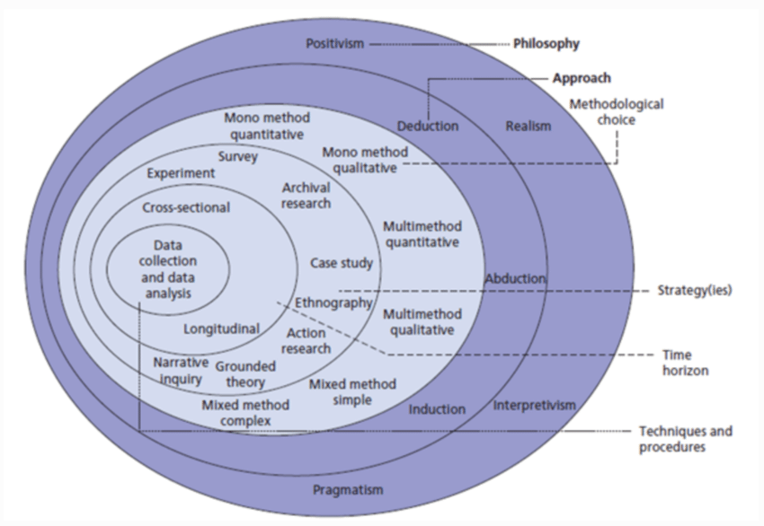

Figure 1: The structure of the Onion Research Model [1].

* + 1. **Philosophy**

Discuss different research approaches and methodology for the Philosophy layer. Provide justification of your choice.

* + 1. **Theory Development Approach**

Discuss different research approaches and methodology for the Development Approach layer.

Provide justification of your choice.

* + 1. **Methodological Choice**

Discuss different research approaches and methodology for the Methodological layer. Provide justification of your choice.

* + 1. **Research Strategy**

Discuss different research approaches and methodology for the Strategy layer.

Provide justification of your choice.

* + 1. **Time Horizons**

Discuss different research approaches and methodology for the Time Horizons layer. Provide justification of your choice.

* + 1. **Techniques and Procedures**

Discuss different research approaches and methodology for the Techniques and Procedures layer.

Provide justification of your choice.

### Research Methodology

Use a chart to show how your work is completed and discuss each part of the chart. An example of a chart is shown in Figure2.

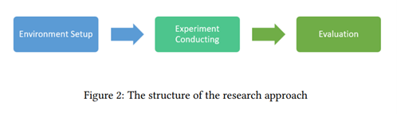

Critically evaluate each part of the chart to justify chosen research methods and analysis.

# Results and Discussion

Discuss the results. Include all tables and figures.

Explain how the results meet the research question and objectives.

Describe merits and limits of the analysis.

# Conclusion and Recommendations

State the aim of the study and summarize the findings.

Based on the findings, discuss the recommendations that you have.

Propose future work (optional).

# Reflections

Avoid generalization and focus on personal development and the research journey in a critical and objective way.

* 1. **Selected Research Methodology**

Reflection of the research process.

Reflection on the merits, limitations, and potential pitfalls of the selected methods.

* 1. **Alternative Research Methodologies**

Alternative research methodologies in view of outcomes.

Lessons learned in view of outcomes.

* 1. **Recommended Actions and Future Considerations**

Use reflection to inform future considerations.

* 1. **Recommended Methodology**

Updated version of paper Methodology (flowchart, block diagram) with discussion.

**References**

[1] A. Melnikovas, “Adapting Research Onion Model for Futures Studies,” [https: //www.semanticscholar.org/paper/Towards-an-Explicit-Research-Methodology-% 3A-Adapting-Melnikovas/dccf54a5a4312ceb2261e1989cda01f73989d735,](https://www.semanticscholar.org/paper/Towards-an-Explicit-Research-Methodology-%3A-Adapting-Melnikovas/dccf54a5a4312ceb2261e1989cda01f73989d735) 2018, [Online; accessed 10-Jan-2024].